**CRM APPLICATION THAT HELPS TO BOOK A VISA SLOT**

**INTRODUCTION**

**DESCRIPTION**

* + - * A visa slot management projects is a system that is used to track and manage the availability of visa slots, which are appoinments that are required for certain visa applications. It might be used by a government agency or a visa processing center to schedule and manage appoinments with applicants.

**PURPOSE**

* + - * + Customer Relationship Management is a technology for managing all your company’s relationships and interactions with customers and potential customers.
        + The goal is simple improve business relationships . A CRM system helps companies stay connected to customers streamline processes , and improve profitability.

**Problem Definition &Design Thinking**

* + - * + **Empathy Map**

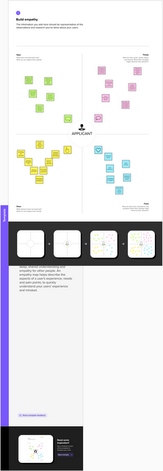

* + - * + **Brainstorming map**

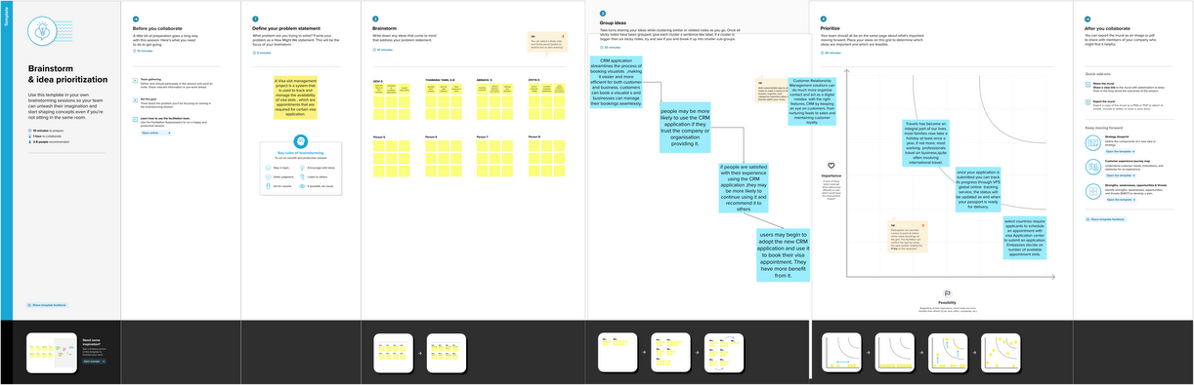

|  |  |
| --- | --- |
| **Object name** | **Fields in the objects** |
| **Obj1**  Passport | |  |  | | --- | --- | | **Field label** | **Data type** | | Contact number | number | | Passport number | text | |
| **Obj2**  Visa | |  |  | | --- | --- | | **Field label** | **Data type** | | Visa slot | Master detail relationship | | Visa slot number | Master detail relationship | |

**Result**

* + - **Data Model**

**Activity & Screenshot**

* + - **CREACTION OF CUSTOM 0BJECT:**

**1.Passport**

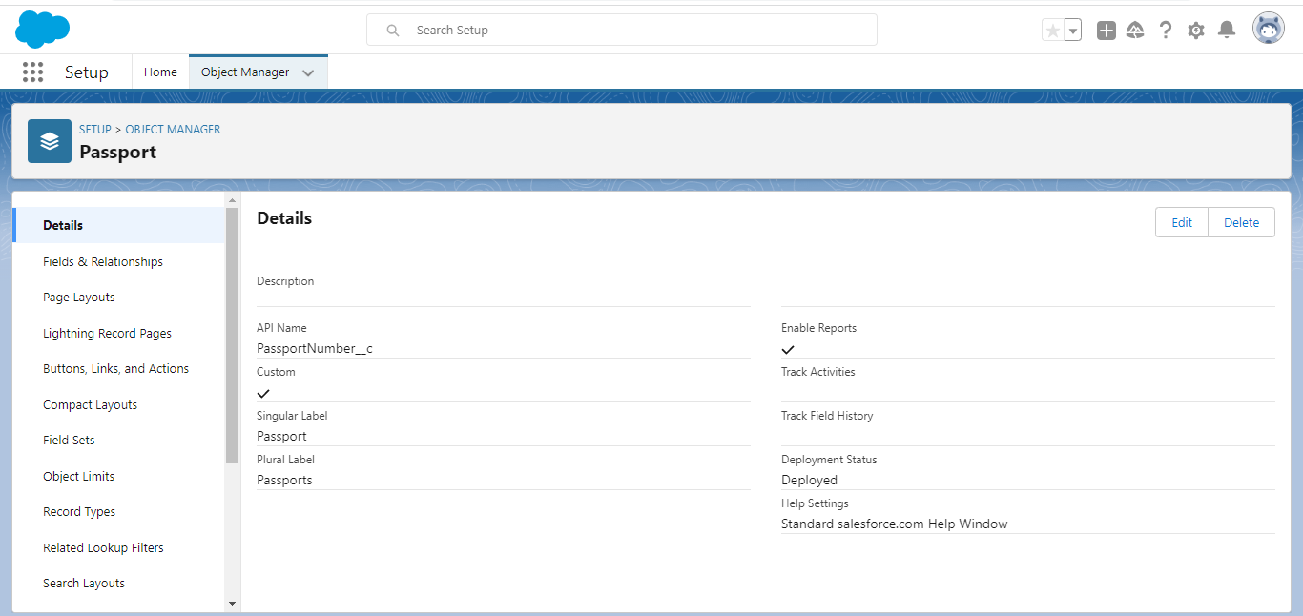

**2.Tab**

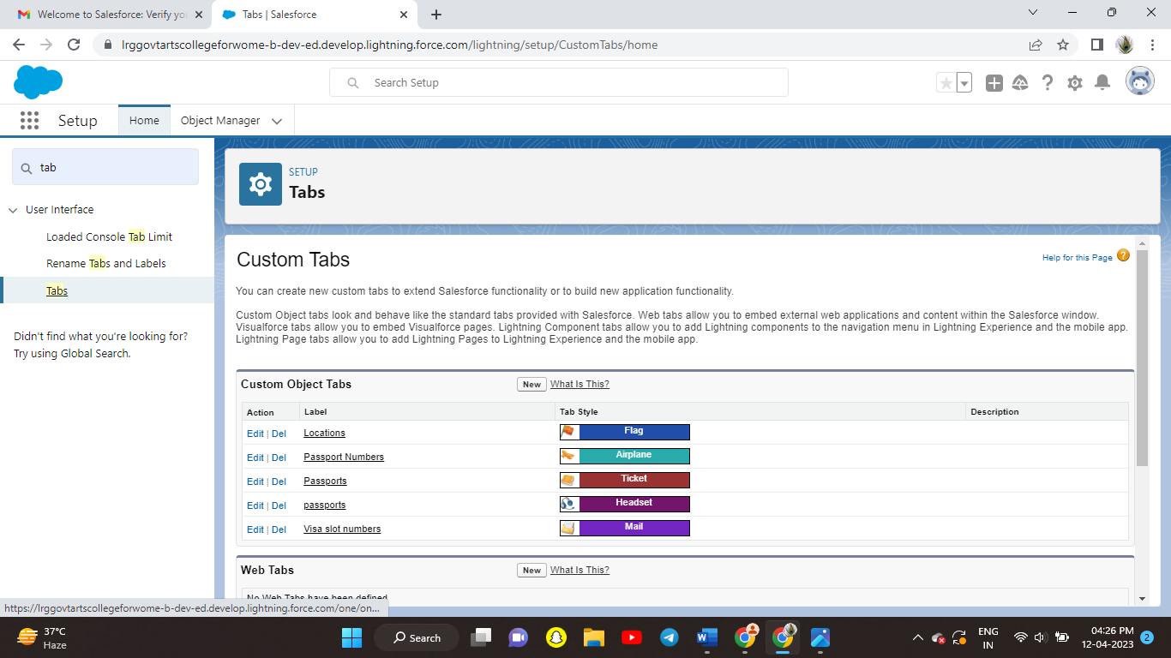

**CREATION OF FIELD ON CUSTOM OBJECT:**

* + - * + Passport

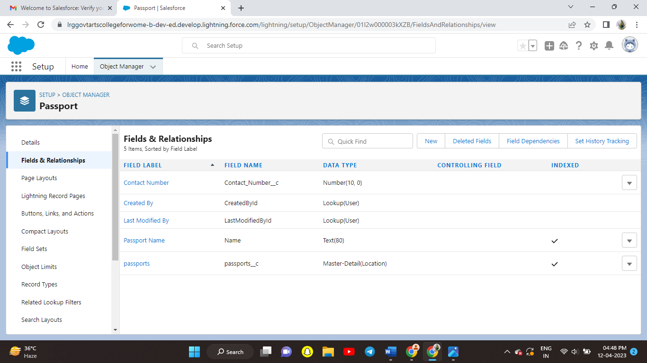

**CREATION OF RELATIONSHIP:**

* + - * + Visa

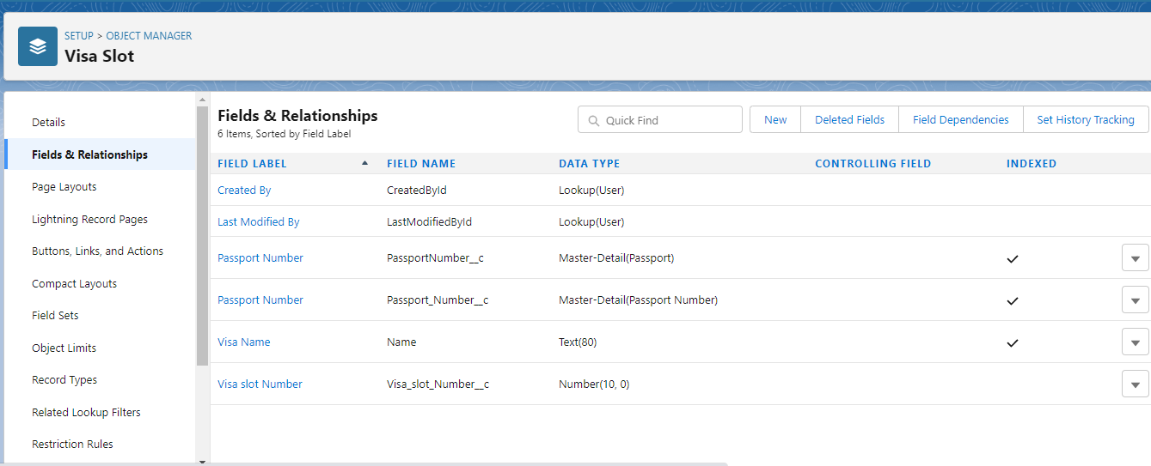

**CREATION OF APP:**

* + - * + Book My Visa App

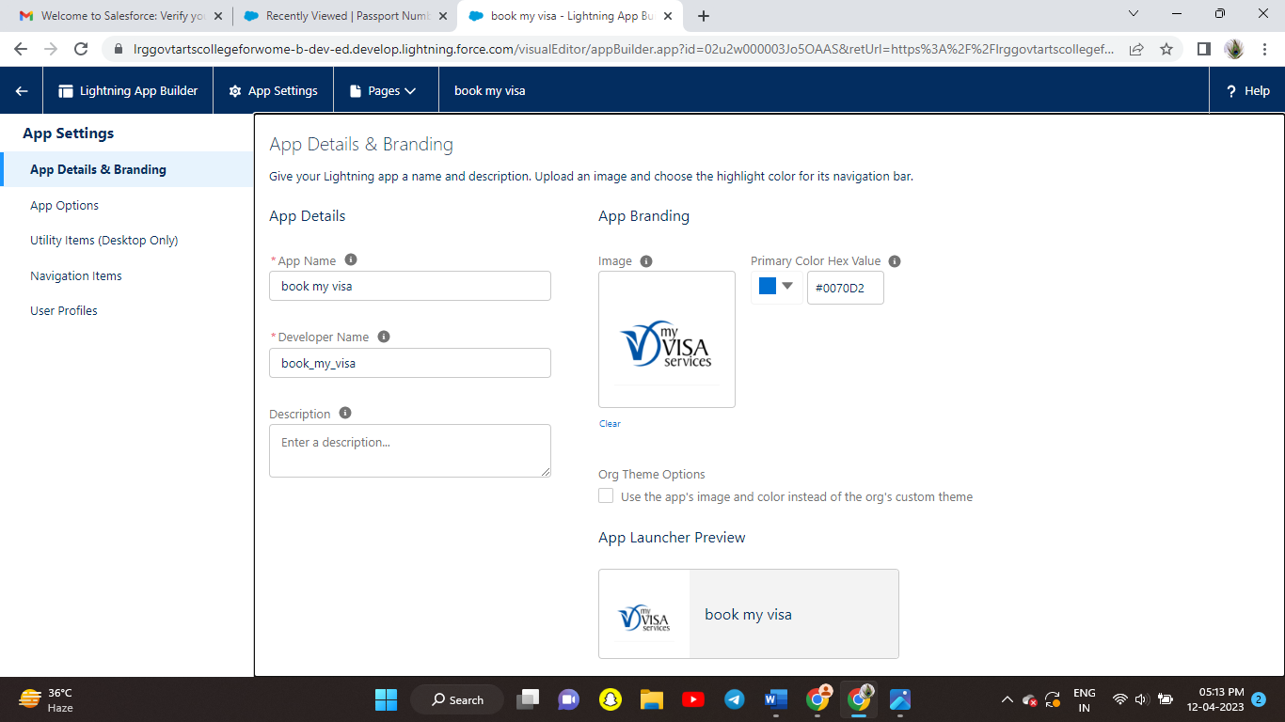

**CREATION OF USER:**

1.User

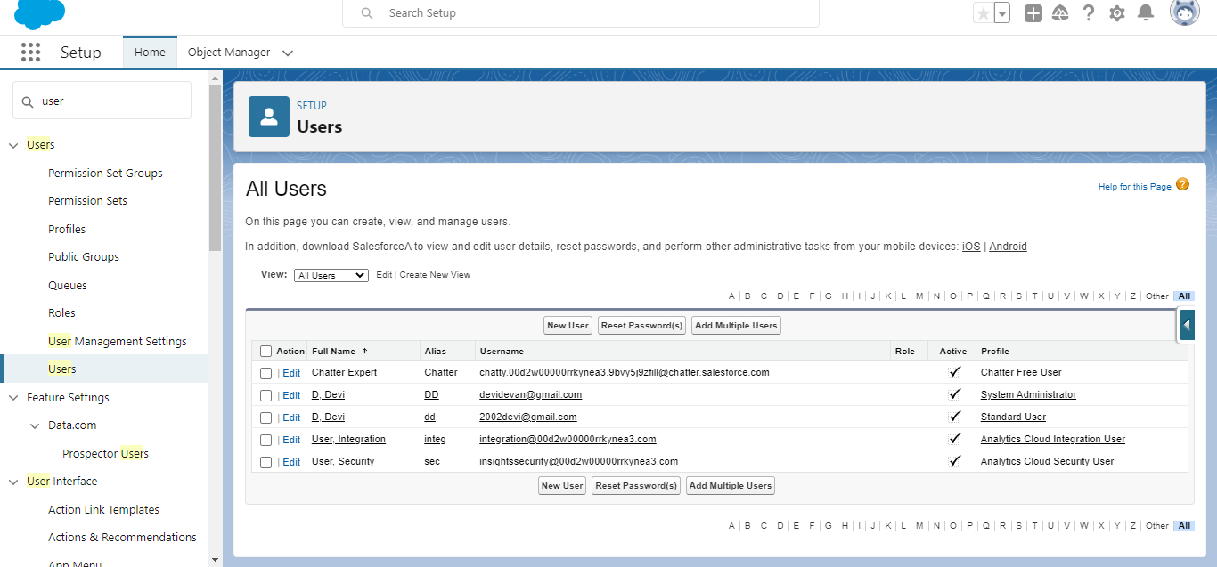

**2.**Organization wide default

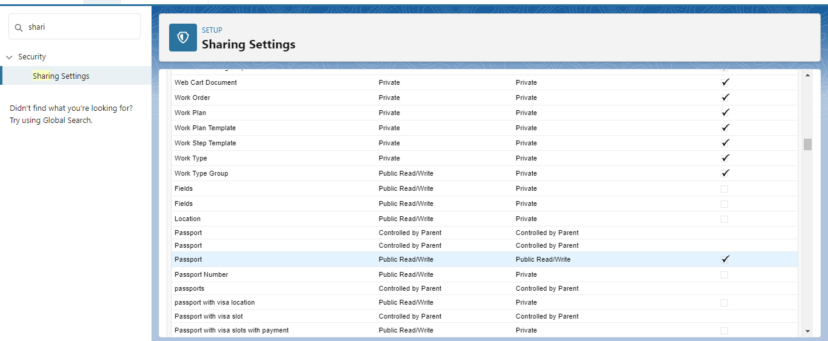

**CREATION OF REPORT:**

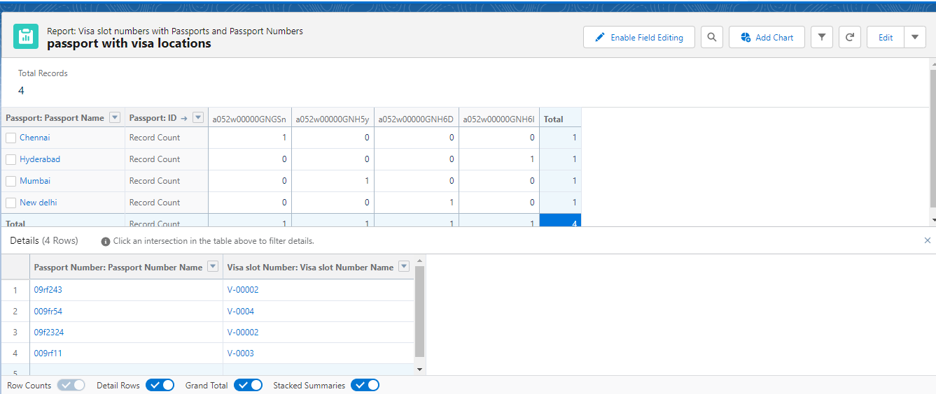

**CREATION OF DASHBOARD:**

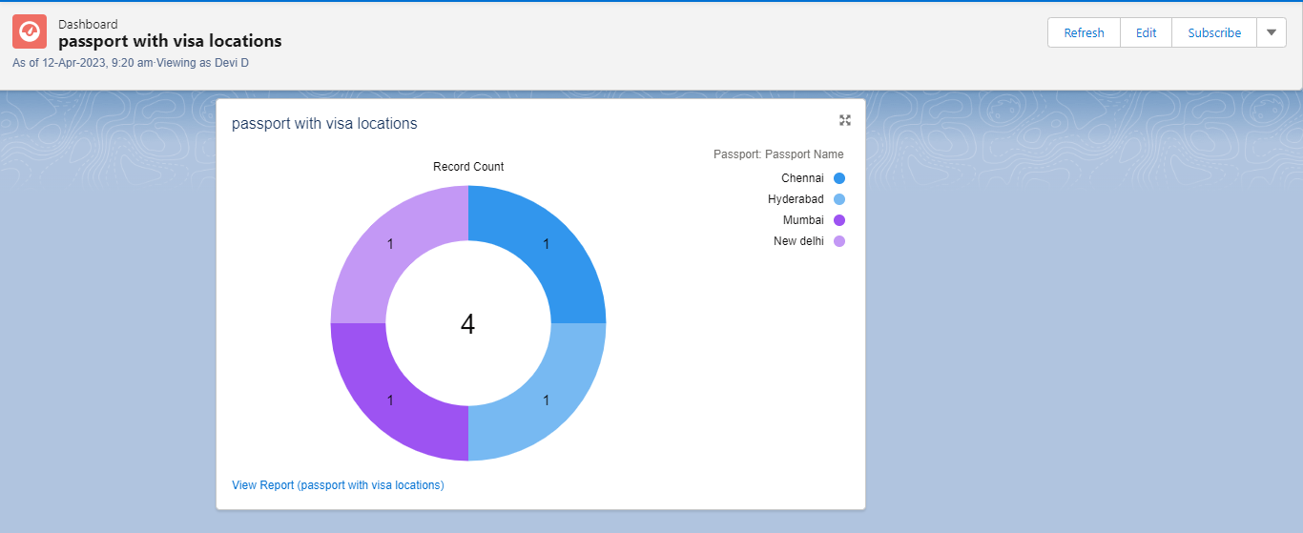

**TRAILHEAD PROFILE PUBLIC URL:**

**Team Lead-** **https://trailblazer.me/id/devid38**

**Team Member1- https://trailblazer.me/id/ttamil30**

**Team Member2:** **https://trailblazer.me/id/aabinaya9**

**Team Member3:** **https://trailblazer.me/id/dibsc1**

**ADVANTAGES:**

* + - * + It increases staff productivity , lowers time costs and boosts morale.
        + It allows for more effective sales and marketing.
        + It can speed up for sales conversion process.
        + It enables widely dispersed teams to work closely.
        + Can improve customer loyalty through exceptional experience.

**DISADVANTAGE:**

* + - * + Staff over-reliance on CRM may diminish customer loyalty through a bad experience.
        + Security concerns associated with centralised data.
        + The excess initial time and productivity cost of implementation.
        + It requires a process- driven sales organisation.
        + It may not suit every business.

**APPLICATIONS:**

CRM application is increasing in importance as it is the largest and fastest growing enterprise application software.A CRM system can give you a clear overview of your customer.you can see everything in one place a simple ,customisable dashboard that can tell you a customer previous history with customer service.

Marketers can uses a CRM solution to manage and optimize campaigns and lead journeys with data driven approach,and better understand the pipelines of sales or prospects coming in,making forcecasting simpler.

This helps to ensure that customer needs are at the forefront of business processes and innovation cycles.

**CONCLUSION :**

* + - * If would probably be particularly difficult to develop and install customer centric strategies.The Customer Relationship Management has simplified the handling of customers in many industries. If CRM application is used must be with the backing of those at the highest level and it must be planned carefully . Therefore, CRM will be the important and better process for customer management.

**FUTURE SCOPE** :

* + - CRM is precited to become more powerful to support customer first, not company first business .customer relationship relationship needs to be flexible, intuitive and collaboration to be successful.
    - The CRM of the future is set to be centralized and empowered by AI and mobile capabilities.
    - CRM applications solution for your business,to determine the CRM scope of the solution you will be implementing. The scope of CRM project means figuring out which years of your business need to be included in the CRM implantation plan.